



Face recognition using machine learning
Now it's time to program your own computer vision facial recognition algorithm (based on supervised learning - a method of machine learning). The goal is to unlock a virtual phone using facial recognition.

Task 1) Create a new project
- Open the page https://machinelearningforkids.co.uk/
- Click on "Let's go" and register as a guest
- Create a new project and name it "ENARIS- CV_FaceLock "
  - In addition, you have to select what exactly you want to recognize => images

Task 2) Create and train a machine learning model
- Click on "Train"
  - Create two new labels: "Access Allowed!" and "Access Denied!"
  - Now add at least 5 photos of yourself with the webcam under the label "Access allowed".
  - Add at least 5 other photos that are not yours to the other label.
  - Go back to the main menu.
- Click on "Learn and test"
  - Read the two pop-ups and follow the "What's next?" instructions.
  - Go back to the main menu.

Task 3) Face-Lock Programming
- Now click on "Make" and select Scratch 3.
Important: Read through the pop-ups, only then will you be familiar with the programming
- Click Project Templates and paste the Face Lock template.
- Create the following program:
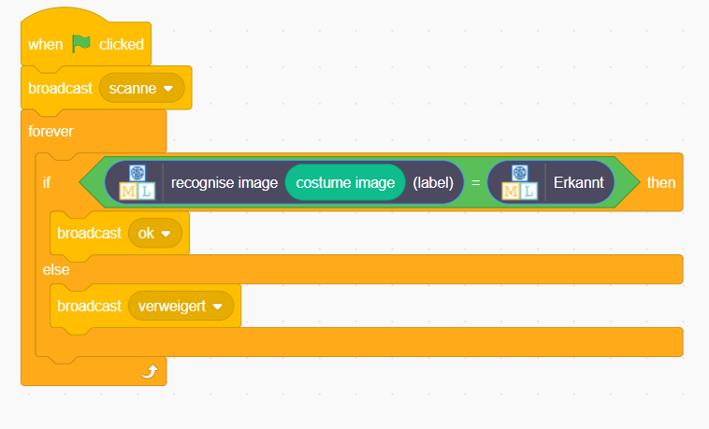
- Switch to the "Costumes" tab and add a new costume with the camera.
  - Once by a person who may have access
  - Once by a person who is not allowed to have access.




- Finally, you still have to update the screen, depending on the state of the program.
  - Click on the "Scenes" field

  - Then return to the "Scripts" tab and add the following script.
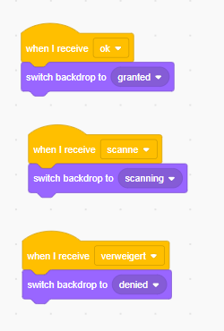

Now your own Supervised Learning Face-Lock is ready!
You can now start the program by clicking on the flag.


